# DATABASE SYSTEMS

# Hassaan Akbar Cheema

# Reg no. 174351

# Bscs6c

# Lab 08

**Task: Write correlated Nested SQL expressions for each of the following queries and execute them:**

1. Find the names of all juniors (Level = JR) who are enrolled in a class taught by ‘Ivana Teach’.

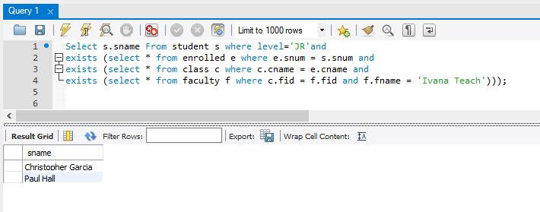

1. Find the names of faculty members that has taught classes only in room R128.

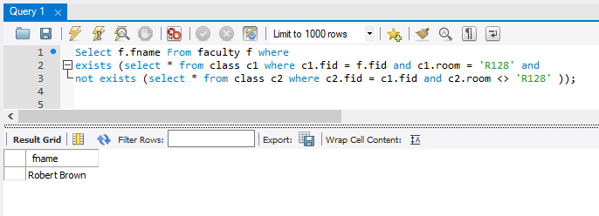

1. Find the names of classes taught by ‘Richard Jackson’ and their times when a class meet there.

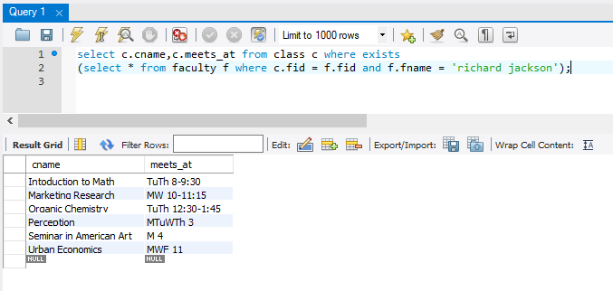

1. Retrieve the snum and sname of students who have taken classes from both ‘Ivana Teach’ and ‘Linda Davis’.

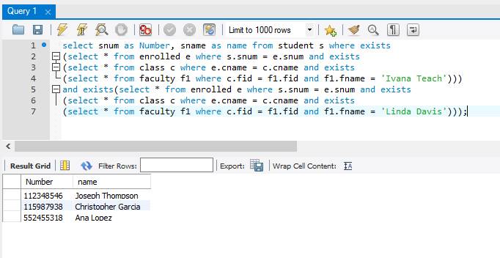

1. Find the age of the oldest students who is enrolled in a course taught by Ivana. Teach.

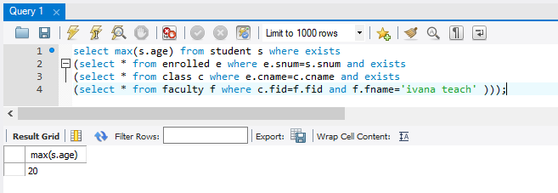

1. Find ages of students in ‘Database Systems’ class that are older than 20 years.

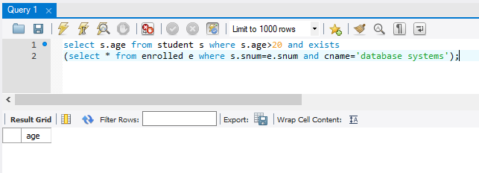

1. Find the name of faculty members that do not teach to class ‘database Systems’.

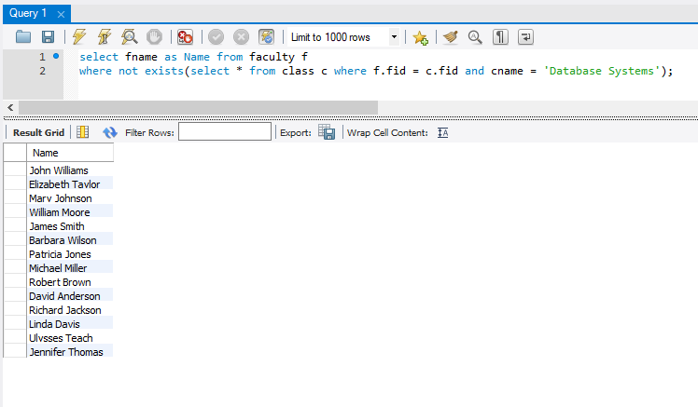

1. Find the name of faculty members who do not teach any course.

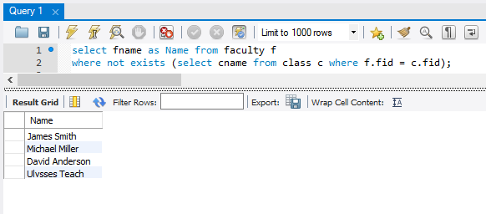

1. Find the name of faculty member, department who taught the maximum number of distinct classes.

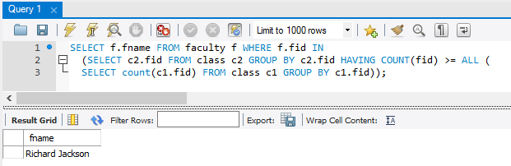

1. Find the names of all those classes and their enrollment strength that have maximum enrollment of students. (Not correlated nested query).

